MongoDB queries

- Insert New Feedback. BASIC
Input: Adding feedback for a customer and loan, capturing sentiments and details about the loan process.
Sample Input:

"loan id": 2001,
"customer_id": 101,
"feedback text": "The loan approval process was seamless, but the interest rate was slightly higher than expected.",

0.7,
"feedback category": "Approval Process", "escalation flag": false,
"escalation reason": null, "timestamp": "2024-1 1 -1 5T1 0:30:OOZ"
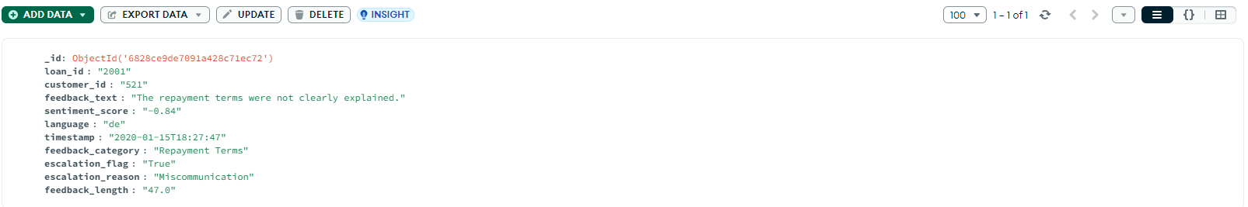

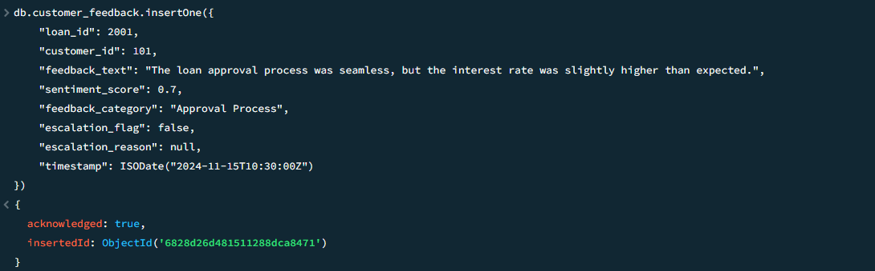

- Update Escalation Flags. BASIC
Input: Update escalation flags in feedback to include specific reasons for unresolved customer complaints.
Sample Feedback Before Update:

"loan id": 2002,
"customer id": 102,
"feedback text ': "Customer service was unresponsive to my queries.", "sentiment score": -0.6,
"feedback category”: "Customer Service", "escalation flag": true,
"escalation reason": null

Feedback After Update:

"loan id": 2002,
"customer id": 102,
"feedback text ': "Customer service was unresponsive to my queries.", "sentiment score": -0.6,
"feedback category": "Customer Service", "escalation flag": true,
"escalation reason”: "Delayed response from customer service"

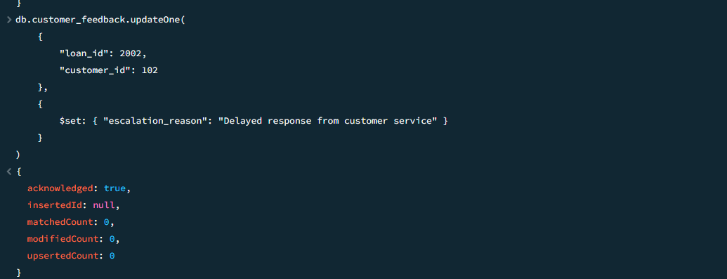

3. Remove Duplicate Behavior Logs. BASIC
Input: Remove duplicate entries with the same customer id and timestamp.

Sample Logs Before Removal:

( ' customer id": 1 03, "timestamp": ' 2024-11-15T12:00:OOZ ', 'action": ”Login", "device": "Mobile" },
( ' customer_id": 1 03, "timestamp": ' 2024-11-15T12:00:OOZ ', 'action": ”Login", "device": "Mobile" }

Logs After Removal:

( ' customer id": 1 03, "timestamp": ' 2024-11-15T12:00:OOZ ', 'action": ”Login", "device": "Mobile" }

- Retrieve Positive Feedback. BASIC
Input: Retrieve feedback entries with sentiment scores greater than 0.5.
Sample Output:

"loan id": 2003,
"customer id": 104,
"feedback_text": ' The repayment terms were flexible and suited my needs.", "sentiment score": 0.9

"loan id": 2004,

”customer id": 1 05,
"feedback text": "Customer service was prompt and helpful during the loan application process.",
"sentiment score": 0.8

5. Fetch Logs for 'Missed Payment' Actions. BASIC
Input: Retrieve behavior logs where the action is "Missed Payment."
Sample Output:

”customer id": 1 06,
"timestamp": "2024-1 0-1 0T08:45:OOZ",
"device": "Desktop",
"ip address”: "192.168.1.1 01"

”customer id": 1 07,
"timestamp": "2024-1 0-12T1 4:00:OOZ",
"device": "Mobile",
"ip address": "1 0.0.0.45"

